Mehdi Bennani Karim

IB Physics Standard Level Internal Assessment

Candidate Number: 006047-0081

School : EF International Academy

Introduction:

From a young age, oscillating objects always fascinated me. At my old house, my family used to own an antic pendulum clock. At times I used to be mesmerized by how the metallic stick would oscillate at a perpetually constant rate.

After being introduced to the physics realm and given the opportunity to investigate one of its facets, I decided to delve into the oscillation of a string. For this reason, I decided to investigate how the length of a string effects the time of a period on a pendulum.

Research Question:

How is the length of a string effect the time of period on a pendulum?

Materials:

* Pendulum Stand
* Wooden Meter stick
* Scissor
* Mass
* Stopwatch
* Cotton String roll
* Three finger clamp

Variables:

**Dependent Variable**:

Time after one period. Using the stopwatch, I measured the time after 10 oscillations then I divided this value by 10 to obtain the period. I used this method to reduce error in measurement because the standard human reaction time is not fast enough to accurately record the time for one oscillation.

**Independent Variable:**

Cotton string length. The length is incrementally decreased following each trial and measured by myself using the meter stick.

**Controlled Variable:**

Environment – The atmosphere in which I proceeded with this experiment was a closed classroom devoid of temperature change, wind, and changes in room pressure.

Properties of string – Throughout this experiment, I used an identical cotton string roll.

Mass – The mass hanging from the bottom of the string was kept constant at 100grams.

Release angle – I set an angle at the beginning of the experiment by marking the pendulum with a red marker.

Stopwatch – I was the only person in charge of recording the time to avoid any additional human errors in the experiment

Method:

1. Start by positioning the pendulum stand at the edge of a table to allow the string, when attached, to reach the ground.
2. Join the three-finger clamp to the pendulum stand at an establish height. In my experiment I choose 80cm.
3. Then tie the cotton string to the three-finger clamp and cut it as the desired length using the scissor and meter stick. For my experiment, I choose increment lengths of 100, 80, 60, 40, 20, 5, 2.5 centimeters.
4. Tie the weight to the bottom end of the cotton string. My establish constant weight for the experiment was 100grams.
5. Proceed by setting the stopwatch. While ensuring that the string is straight for the whole process, hold the weight at the established angle and release it.
6. Record the time following 10 oscillations.
7. Repeat step 5&6 for 5 trials.
8. Shorten the length of the string to the following increment by cutting the cotton string using scissors prior to measuring. Tie the string back to the pendulum and proceed to repeat step 5,6, and 7 for this string length.

Diagram:

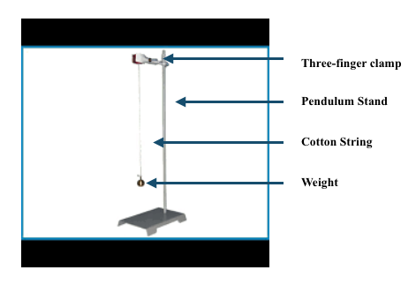

Raw Data:

|  |  |  |  |  |  |  |  |  |  |  |  |
| --- | --- | --- | --- | --- | --- | --- | --- | --- | --- | --- | --- |
|  | **10 Oscillations(s)** | | | | | | | | |  | |
| **Length of String(cm) ±0.5** | Trial 1 |  | Trial 2 |  | Trial 3 |  | Trial 4 |  | Average | | Errors± | |
| 100 | 21.2 |  | 20.9 |  | 21.0 |  | 21.2 |  | 21.1 | | 0.1 | |
| 80 | 18.5 |  | 18.9 |  | 18.5 |  | 18.8 |  | 18.7 | | 0.3 | |
| 60 | 16.3 |  | 16.2 |  | 16.6 |  | 16.4 |  | 16.3 | | 0.2 | |
| 40 | 13.1 |  | 13.5 |  | 13.5 |  | 14.6 |  | 13.7 | | 0.2 | |
| 20 | 9.7 |  | 9.9 |  | 10.0 |  | 9.8 |  | 9.8 | | 0.1 | |
| 10 | 7.6 |  | 7.5 |  | 7.4 |  | 7.5 |  | 7.5 | | 0.1 | |
| 5.0 | 6.2 |  | 6.2 |  | 6.1 |  | 6.1 |  | 6.1 | | 0.1 | |
| 2.5 | 5.4 |  | 5.5 |  | 5.3 |  | 5.3 |  | 5.4 | | 0.1 | |

Converting :

After gathering the raw data, I proceeded to convert the 10 oscillations to period.

Example :

Length = 100 cm

Average = 21.1 seconds

21.1 seconds / 10 Oscillations = 2.11 seconds = period

Calculating Error:

Using excel software, I calculated error using standard deviation. (=STDEV).

|  |  |  |  |  |  |
| --- | --- | --- | --- | --- | --- |
| **Length of String(cm) ±0.5** |  | **Period(s)** |  | **Error(s)** |  |
| 100 |  | 2.11 |  | 0.1 |  |
| 80 |  | 1.87 |  | 0.3 |  |
| 60 |  | 1.63 |  | 0.2 |  |
| 40 |  | 1.37 |  | 0.2 |  |
| 20 |  | 0.98 |  | 0.1 |  |
| 10 |  | 0.75 |  | 0.1 |  |
| 5.0 |  | 0.61 |  | 0.1 |  |
| 2.5 |  | 0.54 |  | 0.1 |  |

Graph:

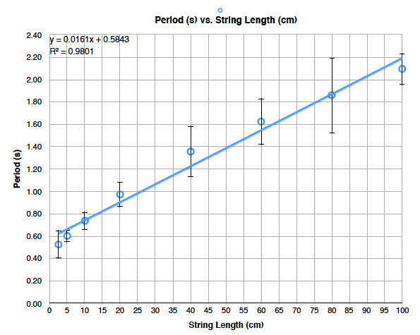

The graph above depicts the Period(s) vs. String Length (cm)

Inferring from the above graph, the graphed data fails to show a linear behavior since there is an uneven distribution of data points between the line of best fit. The points seem to show a curved behavior since the data points start and end below the trend line and are above the trend line on the middle points.

Manipulating Data:

|  |  |  |  |  |  |
| --- | --- | --- | --- | --- | --- |
| **Length of String(cm) ±0.5** |  | **Period(s^2)** |  | **Error(s^2)** |  |
| 100 |  | 4.4 |  | 0.1 |  |
| 80 |  | 3.47 |  | 0.4 |  |
| 60 |  | 2.65 |  | 0.3 |  |
| 40 |  | 1.85 |  | 0.3 |  |
| 20 |  | 0.96 |  | 0.2 |  |
| 10 |  | 0.55 |  | 0.2 |  |
| 5.0 |  | 0.37 |  | 0.2 |  |
| 2.5 |  | 0.29 |  | 0.5 |  |

*Error Calculation was done through excel (=STDEV)

Manipulating the data to find a linear relationship proved itself to be challenging at the beginning after trying a variety of possibilities by using logs, square root, and squaring. Prior to trying different combinations of manipulations, I discovered that by squaring the period, the results generated an appropriate linear relationship as demonstrated by the graph below.

Example of Data processing:

String length – 100cm

Average Period – 2.11

(2.11 seconds)2 = 4.4 seconds2

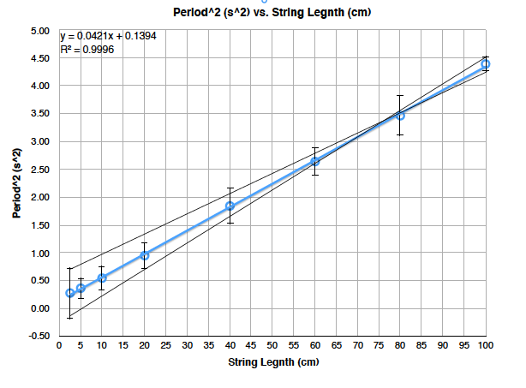

Max/Min Slope =

MIN 🡪 y = 0.037x + 0.621 Slope min 🡪 m = 0.037

MAX 🡪 y = 0.0482x – 0.272 Slope max 🡪 m = 0.0482

Calculating uncertainty 🡪 ( Slope max – Slope min ) / 2

= (0.0482 – 0.037) / 2

= 0.0056

**Conclusion:**

This experiment, which investigated the relationship between the length of a string and time of a period on a pendulum, turned out to be rather successful since I was able to draw a linear relationship out of the data. Initially, the raw data collected portrayed a parabolic relationship since the points start and end at the bottom of the trend line and are above the trend line on the middle points. After attempting to manipulate the data by using logs, square root, and square to alter the variables, I came to the conclusion that by squaring the period, the data showed itself to be responsive by showing a linear relationship as shown by the graph Period^2 vs. Length of string. It is also possible to infer this relationship from the R^2 value of 0.9996 since it is close to 1. Based on the relationship created by manipulating the data, I deduce that for each centimeter, the period2 increases by 0.042± 0.006.

Throughout this experiment, I encountered few systematic errors due to the simply materials of measurement used. (stopwatch & ruler). The errors that proved to be more present are the random ones. This is the case because for a major part of this experiment, I had to depend on my human capabilities of preserving a correct launch angle and precisely defining the time after 10 oscillations.

**Evaluating Procedure:**

Despite finding satisfying results, this experiment’s procedure contains a variety of limitations and weaknesses. Although I conducted this experiment in a closed environment, air resistance is a factor that affected my data because I was not able to preform this experiment in a vacuum. Another issue was launching the weight attached to cotton string in a straight back and forth motion. The weight had a tendency to twirl in a circular motion instead.

Moreover, I experienced another problem when measuring the time. The accuracy of the measurement was restricted to my human capabilities. It’s worth noting that the average human reaction has an approximate range of 150 to 300 milliseconds. During the time of my experiment, other people were moving in the same room. Although I attempted to keep the environment as constant as possible, the traffic in the room might have slightly affected my data.

**Improving Investigation:**

A variety of aspects of this experiment can be enhanced. The process of recording data can by improved by filming all of the oscillations. Filming with an average quality camera would allow me to view the video in slow motion and accurately record the time after 10 oscillations. It is also possible to further improve this experiment by conducting it in the most closed environment possible. If I were to redo this experiment, I would lock myself in a room and shut all doors and windows to monitor air flow. Regarding the circular motion issue of the mass, I should define a clear launching method that limits the circular motion. Tying the string to the mass in a way that equally distributes its weight on each side could limit the circular motion. This will facilitate the back and forth motion.